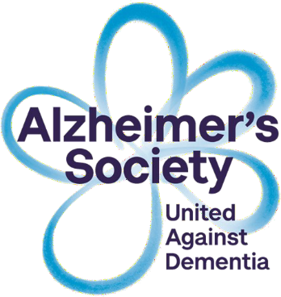

MEMORY SUPPORT WORKER SERVICE
for
people living with memory problems in
the Leeds area

If you are worried about your memory or need
information and support please contact us on:
Telephone: 0113 231 1727

(Opening times are 9.00am - 5pm Monday to Friday) E-mail: memorysupport.lypft@nhs.net

National Dementia Helpline—the live online advice offered by Alzheimer’s Society is open 9am-12pm Monday to Friday and 6pm-8pm Mondays at www.alzheimers.org.uk.

Produced and updated by Alzheimer’s Society 22/03/2022

Alzheimer’s Society is a registered charity in England and Wales (296645) and the Isle of Man (1128)
A Company limited by guarantee and registered in England and Wales (2115499) and the Isle of Man (5730F) Registered Office: Alzheimer’s Society, 43-44 Crutched Friars, London, EC3N 2AE

About Alzheimer’s Society
Alzheimer’s Society is the UK’s leading support and research charity for people with dementia, their families and carers. We provide information and support to people with any form of dementia and their carers through our services, publications, National Dementia Helpline and local offices. We campaign for a better quality of life for people with dementia and a greater understanding of dementia. We also fund an innovative programme of medical and social research into the cause, cure, and prevention of dementia and the care people receive.

About the Memory Support Worker Team
The Memory Support Worker service was commissioned by Leeds Clinical Commissioning Groups and is delivered by a partnership between the Alzheimer’s Society and Leeds and York Partnership (NHS) Foundation Trust. The service was set up in October 2015.

Our Memory Support Worker service was developed to provide personalised information, support and advice to people with memory problems, their families and carers. This can include signposting to local services like our activity groups, and helping service users to strengthen existing support networks so that they can maintain their independence for as long as possible. The service we provide is flexible, but consist essentially of person-centred, helpful conversations and support.
We have 14 Memory Support Workers working around the Leeds area. We receive referrals from the Memory Service and other agencies but we can also receive self referrals.
The Memory Support Workers also work closely with local GP practice teams, the Memory Service team including occupational therapist, consultant psychiatrist, nurses and the Younger People with Dementia Team.

Do you have memory problems?

Our Memory Support Workers can help with:
- Information and advice for you (or the person you know) about memory problems
- Family and carers support and details on how to contact services that could help
- Be a contact person for people living at home with dementia/ memory problems and their family and carers
- To help you to make informed choices about living well with dementia and other memory problems.

For more information contact:-

Email: memorysupport.lypft@nhs.net

To speak to a Memory Support Worker regarding any issues you may have, please call the Leeds Alzheimer’s Society on 0113 2311727.

Other support available

Dementia Connect support line on 0300 150 3456
The support line is open 9am-8pm Monday to Wednesday, 9am-5pm Thursday and Friday and 10am-4pm Saturday and Sunday. However, the service may be closed occasionally during these times for operational reasons or because of staff shortages. Calls charged at standard rate.

Our website - alzheimers.org.uk
Our website is filled with information about dementia including over 80 factsheets, information on national diagnosis rates, frequently asked questions and much more. Includes links to local services.

